

ASSET VERIFICATION AND RECORDING TOOL KIT


Plot 31, Bukoto Street
P.O Box 7657, Kampala, Uganda
+256 (0) 39 2000216/0772525235
email: cpa@cpa.ug

www.cpa.com

August to September 2026

VERIFICATION DETAILS

NAME OF THE REGION: | WESTERN REGION
SUB-REGION: | BUNYORO
Name of Local Government | KAKUMIRO DISTRICT LOCAL GOVERNMENT
VERIFIER PARTICULARS
Full name | NAKAGWA HINDU, FATUMAH YASIN, NAKITENDE SHARIFAH
Contact/ email and Telephone | 0702578692 hindunakagwa@gmail.com  0703480094  0703780913
Supervisor/ Sub team leader
Name

Contact
Date of submission

HEALTH CENTRES
INFORMANT INTERVIEW/DISCUSSION GUIDE (INCHARGE OR RESPONSIBLE PERSON)

Name of Health Centre: KITAHUKA HEALTH CENTRE III

1a | Does the Facility have a record of all assets provided under UgIFT.  (Obtain a record and verify if it has the costs and numbers supplied | YES
1b | If Not ask how many were supplied and when.

2 | How does this facility Maintain (repair/service/replace) the assets provided under UgIFT  Repairs and servicing of the assets are carried out using PHC funds. Where necessary, damaged or non-functional equipment is repaired, serviced, or replaced to ensure continuity of service delivery.

3 | Does the facility take regular record about functionality/ or breakdown of the assets provided? | YES. The facility maintains regular records on the functionality and breakdown of the assets and equipment provided.

4 | How has the UgIFT support helped in service delivery in the area, any issues, challenges and any recommendations for better program implementation. | UGIFT SUPPORT: IMPACT, CHALLENGES AND RECOMMENDATIONS  Impact on Service Delivery  UgIFT support has significantly improved service delivery by equipping the health facility with essential medical equipment needed to provide quality healthcare services to the community.  Challenges Faced  - The ambu bag masks supplied were not of the appropriate standard sizes for adults, babies, and premature infants, making them difficult to use effectively.  - Repair and maintenance of the supplied equipment is costly. This makes it difficult for the facility to maintain the equipment, particularly because of inadequate operational funds.  Recommendations  - UgIFT should ensure that medical equipment supplied meets the appropriate specifications and standard sizes for different categories of patients, including adults, babies, and premature infants.  - UgIFT should consider providing support for the repair and maintenance of the supplied equipment to ensure that it remains functional and sustainable.  - Additional operational funding should be considered to enable the facility to maintain and service the equipment provided under the programme.  Findings  The equipment supplied under UgIFT were available at the health facility however they did not have visible UgIFT identification numbers. Although the items had engraved marks indicating that they were supplied under UgIFT, the engraved marks did not clearly display the UgIFT identification numbers.

PROCEED TO VERIFICATION AFTER THIS DISCUSSION

Health centre checklist

NAME OF LG KAKUMIRO DISTRICT LOCAL GOVERNMENT NAME OF HEALTH FACILITY KITAIHUKA HEALTH CENTRE III

Equipment/ Item | Department | Asset Number | Item  Description | Life in Months | Tag Number ( engrave no.) | Date Of Purchase | Date Placed In Service | Recoverable cost | Cost | Acc Dep Cost | Net Book Value | Ytd Deprn | Equipment status | Remarks
- P. Machine, Digital | OPD, MATERNITY |  | It has a start/stop button white in colour and a cuffs wrapped around the upper arm.  It is operated using batteries |  | KMR/KTHK-2024-HCIII |  | 2024 |  |  |  |  |  | Functioning | Received 2 machines and one in use.
B.P. Machine (Aneroid wall mounted) | OPD, MATERNITY |  | It doesn’t use batteries. It has a round pressure gauge/ dial with numbers usually from 300mmHg.  Its usually put on the wall. |  | KMR/KTHK-2024-HCIII |  | 2024 |  |  |  |  |  | Functioning | Received 2 machines and one in use.
Autoclave 20 Liters.,Duo Operated | MATERNITY & STORE |  | It’s a large, strong metal chamber with a door, pressure temperature & operating controls |  | KMR/KTHK-2024-HCIII |  | 2024 |  |  |  |  |  | Functioning and the other spoilt | Received 2 machines.  One in use
Bowl, Kick | STORE |  | Stainless steel bowl or basin |  | KMR/KTHK-2024-HCIII |  | 2024 |  |  |  |  |  | Functioning | Received 2 pieces and still kept on store
Bowl Stand | MATERNITY |  | Metal frame stand with three legs |  | KMR/KTHK-2024-HCIII |  | 2024 |  |  |  |  |  | Functioning | Received 2 pieces and still kept on store
Counting chamber Neubauer- Improved | STORE |  | Small rectangular glass plate. It has a special raised chamber where the sample is placed |  | KMR/KTHK-2024-HCIII |  | 2024 |  |  |  |  |  | Functioning | Received two pieces and still kept in store.
Cupboard Steel, Lockable | IN CHARGE’S OFFICE. |  | - It is metallic.  - Has 2doors  - Has a lock and key  - It has shelves inside for keeping in documents or equipments |  | KMR/KTHK-2024-HCIII |  | 2024 |  |  |  |  |  | Functioning | Received 2 pieces and all in use.
Drip Stand | MATERNITY, OPD & IN PATIENTS |  | - Long vertical metal pole with a stable base having five legs.  - It has hooks at the top for hanging on fluid bags |  | KMR/KTHK-2024-HCIII |  | 2024 |  |  |  |  |  |  | Received 9 pieces and all in use.
ESR Stand | STORE |  | A small white rectangular metal with several holes for holding ESR tubes |  | KMR/KTHK-2024-HCIII |  | 2024 |  |  |  |  |  | Functioning | Received one piece Not yet in use and still kept in store.
Examination Couch | OPD ANTENATAL, EXAMINATION ROOM |  | - Its rectangular in shape with a mattress.  - It has a back rest which is adjustable.  - It has four metallic legs.  - It has a head and lower body section |  | KMR/KTHK-2024-HCIII |  | 2024 |  |  |  |  |  | Functioning | Received 6 pieces and all in use
Examination light,LED | N/A |  |  |  | N/A |  | N/A |  |  |  |  |  | N/A | Did not receive
Glucometer | LAB, |  | - White in colour.  - Digital meter screen with test strrips. |  | KMR/KTHK-2024-HCIII |  | 2024 |  |  |  |  |  | Functioning | Received 1piece.
Haemoglobin Meter, Digital | LAB |  | - White Small rectangular electronic device.  - Has digital screen  - Has an opening where a test strip containing blood is inserted. |  | KMR/KTHK-2024-HCIII |  | 2024 |  |  |  |  |  | Functioning | Received 1 piece and in use.
Height Meter | OPD |  | - It’s a tall vertical measuring rod marked in centimeters  - It has a stable base where a person stands.  - It has a sliding head piece that is lowered to touch the top of the person’s head. |  | KMR/KTHK-2024-HCIII |  | 2024 |  |  |  |  |  | Functioning | Received 2. and in use.
Instrument Trolley | MATERNITY |  | Its metallic with two trays and four wheels for easy movement |  | KMR/KTHK-2024-HCIII |  | 2024 |  |  |  |  |  | Functioning | Received 2 pieces and in use.
Microscope Binocular | LAB |  | Has two eye pieces at the top  Has a strong base and supporting arm |  | KMR/KTHK-2024-HCIII |  | 2024 |  |  |  |  |  | Functioning | Received 1 piece and in use.
Otoscope | STORE |  | - Handheld instrument used to look inside the ear.  - The handle contains batteries  - Its black in colour. |  | NOT ENGRAVED |  | 2024 |  |  |  |  |  | Functioning | Received one and not yet in use still kept in store.
Patient Screen | GENERAL WARD |  | Its blue in colour and tall folding screen and washable.  Has wheels for easy movement |  | KMR/KTHK-2024-HCIII |  | 2024 |  |  |  |  |  | Functioning | Received 6 pieces and In use
Patient Trolley | OPD, MATERNITY |  | - Has wheels for easy movement  - Has a mattress where a patient lies.  - It has adjustable back rest  - Ithas push handles at the head and foot end  - Has lockable wheels or brakes for safety. |  | KMR/KTHK-2024-HCIII |  | 2024 |  |  |  |  |  | Functioning | Received 2 pieces and in use
Refrigerator, Basic | LABOUR SUITE & STORE |  | White in colour |  | KMR/KTHK-2024-HCIII |  | 2024 |  |  |  |  |  |  | Received 2 pieces and in use
Stethoscope | STORE |  | Has 2 ear pieces at the top  It has flexible rubber tubing connecting the earpieces to the chest piece.  Has a metal chest piece. |  | Not Engraved |  | 13/05/2024 |  |  |  |  |  | Functioning | Received 8 pieces and in use
Stop Watch | STORE |  | - Its plastic.  - Has a stop and stop button.  - Has digital display showing minuted seconds. |  | KMR/KTHK-2024-HCIII |  | 2024 |  |  |  |  |  | Functioning | Received one piece and still kept in store.
Stretcher | OPD |  | - Has four wheels with brakes.  - Has side rails to help prevent falls.  - Has a long flat mattress  - Has an adjustable back rest.  - Has handles at the head and foot end.  - They are black in colour |  | KMR/KTHK-2024-HCIII |  | 2024 |  |  |  |  |  | Functioning | Received two pieces and in use
Stove, Gas | STORE |  | Metallic gas plates |  | KMR/KTHK-2024-HCIII |  | 2024 |  |  |  |  |  | Functioning | Received 2 pieces and not yet in use. Still kept in store.
Weighing Scale with Height Meter, Adult | OPD |  | - Has a wide plat form where adults stand.  - Has a weight display.  - Has a sliding height meter that rests gently on top of the head. |  | KMR/KTHK-2024-HCIII |  | 2024 |  |  |  |  |  | Functioning | Received 4 pieces and in use.
Weighing Scale, Infant | MATERNITY & STORE |  | - White in colour with a shallow, curved weighing tray where the baby lies.  - Has a digital weight display. |  | KMR/KTHK-2024-HCIII |  | 2024 |  |  |  |  |  | Functioning | Received 2 pieces and in use
Weighing Scale, Toddler | EPI & STORE |  | - Has digital weight display.  - Has a plat form where toddlers stand. |  | KMR/KTHK-2024-HCIII |  | 2024 |  |  |  |  |  | Functioning | Received 2 pieces. One in use and the other still kept in store
Wheel Chair | OPD, MATERNITY |  | - Has two large wheels with hand rims  - Has two small front wheels  - Has arm rests for support, foot rests for the user’s feet.  - It has brakes to keep the wheel chair stationary.  - Has push handles at the back for an attendant |  | Not Engraved |  | 2024 |  |  |  |  |  | Functioning | Received 4 pieces and in use..
Audio Visual Equipment | N/A |  | N/A |  | N/A |  | N/A |  |  |  |  |  | N/A | Did not receive .
Medical Waste Bin | MATERNITY & OPD |  | Metallic containers |  | KMR/KTHK-2024-HCIII |  | 2024 |  |  |  |  |  | functioning | Received 20 pieces and they are in use
Wall Clock | OPD,  INCHARGE OFFICE |  | - White in colour and round with numbers or markings.  - Has a hour and minute hand  - Has a hook for hanging it.  - It operates on a battery. |  | KMR/KTHK-2024-HCIII |  | 2024 |  |  |  |  |  | Functioning | Received 4 pieces and one is in use while others are still kept in store.
Diagnostic Equipment Set for MCH | STORE |  | Medical kit containing instruments to assess mothers newborns infants and children |  | KMR/KTHK-2024-HCIII |  | 2024 |  |  |  |  |  | Functioning | Received one set and not yet in use. Still kept in store.
Diagnostic Equipment Set for OPD | STORE |  | Medical case or kit containing instruments that examine and monitor patients at OPD. |  | KMR/KTHK-2024-HCIII |  | 2024 |  |  |  |  |  | Functioning | Received 2 sets and not yet in use. Still kept in store.
Glassware Set, Laboratory, Basic | STORE |  | A set laboratory glassware consisting of test tube, beakers, measuring cylinders, flasks, pipettes and other glass items used for laboratory testing and sample preparations. |  | KMR/KTHK-2024-HCIII |  | 2024 |  |  |  |  |  | Functioning | Received one set and not yet in use. Still kept in store.
Hollow Ware Set, Treatment | STORE |  | It’s a set of stainless steel medical containers used for holding instruments and other materials during patient treatment. |  | KMR/KTHK-2024-HCIII |  | 2024 |  |  |  |  |  | Functioning | Received one set and not yet in use. Still kept in store.
Instrument Set, Dressing | STORE |  | It’s a stainless steel dressing instrument set consisting of forceps, scissors kidney dish etc used for wound dressing and minor procedures. |  | KMR/KTHK-2024-HCIII |  | 2024 |  |  |  |  |  | Functioning | Received 1 set and still kept in store
Instrument Set, Basic ENT | STORE |  | A basic instrument set containing ear and nasal instruments for examining minor procedures of the ear, nose and throat. |  | KMR/KTHK-2024-HCIII |  | 2024 |  |  |  |  |  | Functioning | Received 2 pieces. One in use and the other one still kept in store
Instrument Set, Suture | OPD & STORE |  | It’s a collection of medical instruments used close and repair wounds in stitches. |  | KMR/KTHK-2024-HCIII |  | 2024 |  |  |  |  |  | Functioning | Received 2 pieces. One in use and the other one still kept in store
Pulse Oximeter, Hand held | MATERNITY & OPD |  | - It uses a battery.  - Has a small main display unit with an LCD screen.  - It has control buttons.  - Has a display showing pulse rate |  | KMR/KTHK-2024-HCIII |  | 2024 |  |  |  |  |  | Functioning | Received 2 pieces and in use.
Bed, Adult Patient with Mattress | POSTNATAL, OPD |  | - Its metallic  - Has a comfortable mattress  - Has four wheels with brakes  - Has side rails for patient safety. |  | KMR/KTHK-2024-HCIII |  | 2024 |  |  |  |  |  | Functioning | Received 16 pieces and in use.
Bed, Pediatric Patient, With Mattress | MATERNITY, OPD |  | - Its metallic.  - Has 4 wheels with brakes.  - Side rails for patient safety.  - Adjustable back rest.  - Has a comfortable mattress |  | KMR/KTHK-2024-HCIII |  | 2024 |  |  |  |  |  | Functioning | Received 4 pieces and in use.
Bedside Locker | WARD |  | - Its metallic  - Has a drawer and a storage part. |  | KMR/KTHK-2024-HCIII |  | 2024 |  |  |  |  |  | Functioning | Received 12 pieces and in use.
Cupboard, Instrument | IN CHARGE’S OFFICE & ANTENATAL |  | Its metallic  Has shelves  Has glass doors |  | KMR/KTHK-2024-HCIII |  | 2024 |  |  |  |  |  | Functioning | In use
Delivery Bed, Hydraulic Manual | MATERNITY |  | - Its blue in colour and has a mattress that is easy to clean.  - It has side rails for patient safety  - It has a removable adjustable delivery section to assist the health worker during child birth.  - Has wheels with brakes for movement and stability.  - Has adjustable back rest and leg section  - Has leg support for delivery |  | KMR/KTHK-2024-HCIII |  | 2024 |  |  |  |  |  | Functioning | Received 1 piece and in use
Oxygen Therapy Apparatus, Mininum 45L cylinder | STORE |  | Has a cylinder valve, flow meter, nasl cannula, oxygen tubing and a cylinder stand for safety movement. |  | KMR/KTHK-2024-HCIII |  | 2024 |  |  |  |  |  | Functioning | Received 2 pieces and in use.
Resuscitator Manual, Infant, with all Mask sizes | N/A |  | N/A |  | N/A |  | N/A |  |  |  |  |  | N/A | N/A
Resuscitator Manual, Adult, with all mask sizes | STORE |  | - Has a large self inflating bag with large transparent face mask.  - Has oxygen tubing |  | Not engraved |  | 2024 |  |  |  |  |  | Functioning | Received 2 pieces and still kept in store.
Suction Apparatus, (Electric) | MATERNITY |  | Has a collection bottle, vacuum gauge, suction tubing and catheter, power switch and electrical cable |  | KMR/KTHK-2024-HCIII |  | 2024 |  |  |  |  |  | Functioning and one use. | Received 1 piece and in use
Nebulizer, Ultrasonic | STORE |  | Has a main electrical unit medicine chamber, patient tubing, face mask, and power cable. |  | KMR/KTHK-2024-HCIII |  | 2024 |  |  |  |  |  | Functioning | Received 2 an still kept in store.
Oxygen Concentrator, Duo Flow | MATERNITY |  | Has 2 oxygen flow meters, oxygen tubing connections ventilation openings and internal compressor. |  | KMR/KTHK-2024-HCIII |  | 2024 |  |  |  |  |  | Functioning | Received 2 pieces and still kept in store.
Bench | N/A |  | N/A |  | N/A |  | N/A |  |  |  |  |  | N/A | Did not see any bench in the facility
Disinfection Buckets | MATERNITY & INJECTION ROOM |  | Its metallic with a lid on top |  | KMR/KTHK-2024-HCIII |  | 2024 |  |  |  |  |  | Functioning | Two buckets were seen in the facility.
Baby Cot | N/A |  | N/A |  | N/A |  | N/A |  |  |  |  |  | N/A | We did not see any baby cot.
Diagnostic Equipment Set for Ward | STORE |  | It’s a collection of basic medical examination instruments packed in a case |  | KMR/KTHK-2024-HCIII |  | 2024 |  |  |  |  |  | Functioning | We only saw 2 pieces but still kept in store
Hollow Ware Set, Ward | N/A |  | N/A |  | N/A |  | N/A |  |  |  |  |  | N/A | We did not find any set during the verification .
Instrument Set, Delivery | STORE |  | It’s a collection of stainless steel instruments used during child birth and related procedures |  | KMR/KTHK-2024-HCIII |  | 2024 |  |  |  |  |  | Functioning | Found 4 in the store .
Instrument Set, Stitch Removing | STORE |  | Small collection of surgical instruments used to remove stitches from healed wounds. |  | KMR/KTHK-2024-HCIII |  | 2024 |  |  |  |  |  | Functioning | Found one set in store
MVA Kit | MATERNITY |  | It’s a set of medical instruments used for uterine evacuation using manual suction. |  | KMR/KTHK-2024-HCIII |  | 2024 |  |  |  |  |  | 3 Functioning | Found 4 kits but one spoilt
Stool, Laboratory | N/A |  | N/A |  | N/A |  | N/A |  |  |  |  |  | N/A | We did not find any during the verification .
Penguin Sucker | MATERNITY |  | Its small soft rubber rounded at one end |  | KMR/KTHK-2024-HCIII |  | 2024 |  |  |  |  |  | Functioning | Found 3 pieces and in use.
Fetoscope, Dopplar | MATERNITY, ANTENATAL & STORE |  | Small handheld electronic unit, has a digital screen, a speaker for hearing the fetal heart beat |  | KMR/KTHK-2024-HCIII |  | 2024 |  |  |  |  |  | Functioning | Found 2 pieces and in use.
Bubble CPAP | N/A |  | N/A |  | N/A |  | N/A |  |  |  |  |  | N/A | We did not find any during the verification .
Centrifuge (Electric) | STORE |  | Its rounded machine, white in colour, it has a digital display and electrical power cable. |  | KMR/KTHK-2024-HCIII |  | 2024 |  |  |  |  |  | Functioning | Found 1 pieces still kept in store
Kangaroo Mother Care Chair | STORE |  | Has padded seat and high supportive backrest , wide armrests to support the mother’s arms |  | KMR/KTHK-2024-HCIII |  | 2024 |  |  |  |  |  | Functioning | Found 1 pieces and still kept in store. .
Radiant Infant Warmer | N/A |  | N/A |  | N/A |  | N/A |  |  |  |  |  | N/A | We did not find any during the verification .
Haemoglobin Meter, Sahli | LAB |  | - Its white in colour.  - Small held electronic machine.  - Has simple buttons. |  | KMR/KTHK-2024-HCIII |  | 2024 |  |  |  |  |  | Functioning | Received 2 pieces and in use.
Delivery Bed | N/A |  | N/A |  | N/A |  | N/A |  |  |  |  |  | N/A | We did not find any during the verification .
Examination light | N/A |  | N/A |  | N/A |  | N/A |  |  |  |  |  | N/A | We did not find any during the verification .
Instrument set, ENT Basic for HCIII | N/A |  | N/A |  | N/A |  | N/A |  |  |  |  |  | N/A | We did not find any during the verification .
Bag Valve mask (Ambu Bag), Neonatal | N/A |  | N/A |  | N/A |  | N/A |  |  |  |  |  | N/A | We did not find any during the verification .
Incubator | N/A |  | N/A |  | N/A |  | N/A |  |  |  |  |  | N/A | Did not find any incubator
Office Chair | OPD, INCHARGE’S OFFICE |  | Padded seat and back rest  Its adjustable  Its black in colour and has wheels. |  | KMR/MKR/HC/UGIFT |  | 13/05/2024 |  |  |  |  |  |  | Found 8 pieces at the facility
Desk | OPD |  | Its wooden brown in colour with a flat top and drawers |  | KMR/MKR/HC/UGIFT |  | 13/05/2024 |  |  |  |  |  | Functioning | Found 1 piece and in use.
Filing Cabinet | STORE |  | Metallic with drawers foe keeping in files |  | KMR/MKR/HC/UGIFT |  | 13/05/2024 |  |  |  |  |  | Functioning | Found 3 piece and in use.
Non Residential Buildings | MATERNITY |  |  |  | NOT ENGRAVED |  |  |  |  |  |  |  | Functioning | Constructed by UGIFT
Residential Buildings | STAFF QUARTER |  |  |  | NOT ENGRAVED |  |  |  |  |  |  |  |  | Constructed by UGIFT

PICTURES OF ASSETS VISITED AND VERIFIED
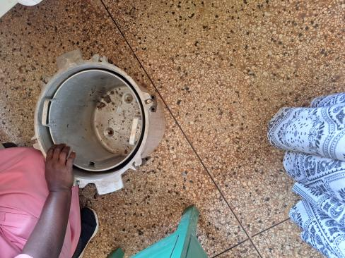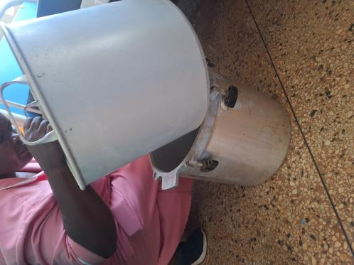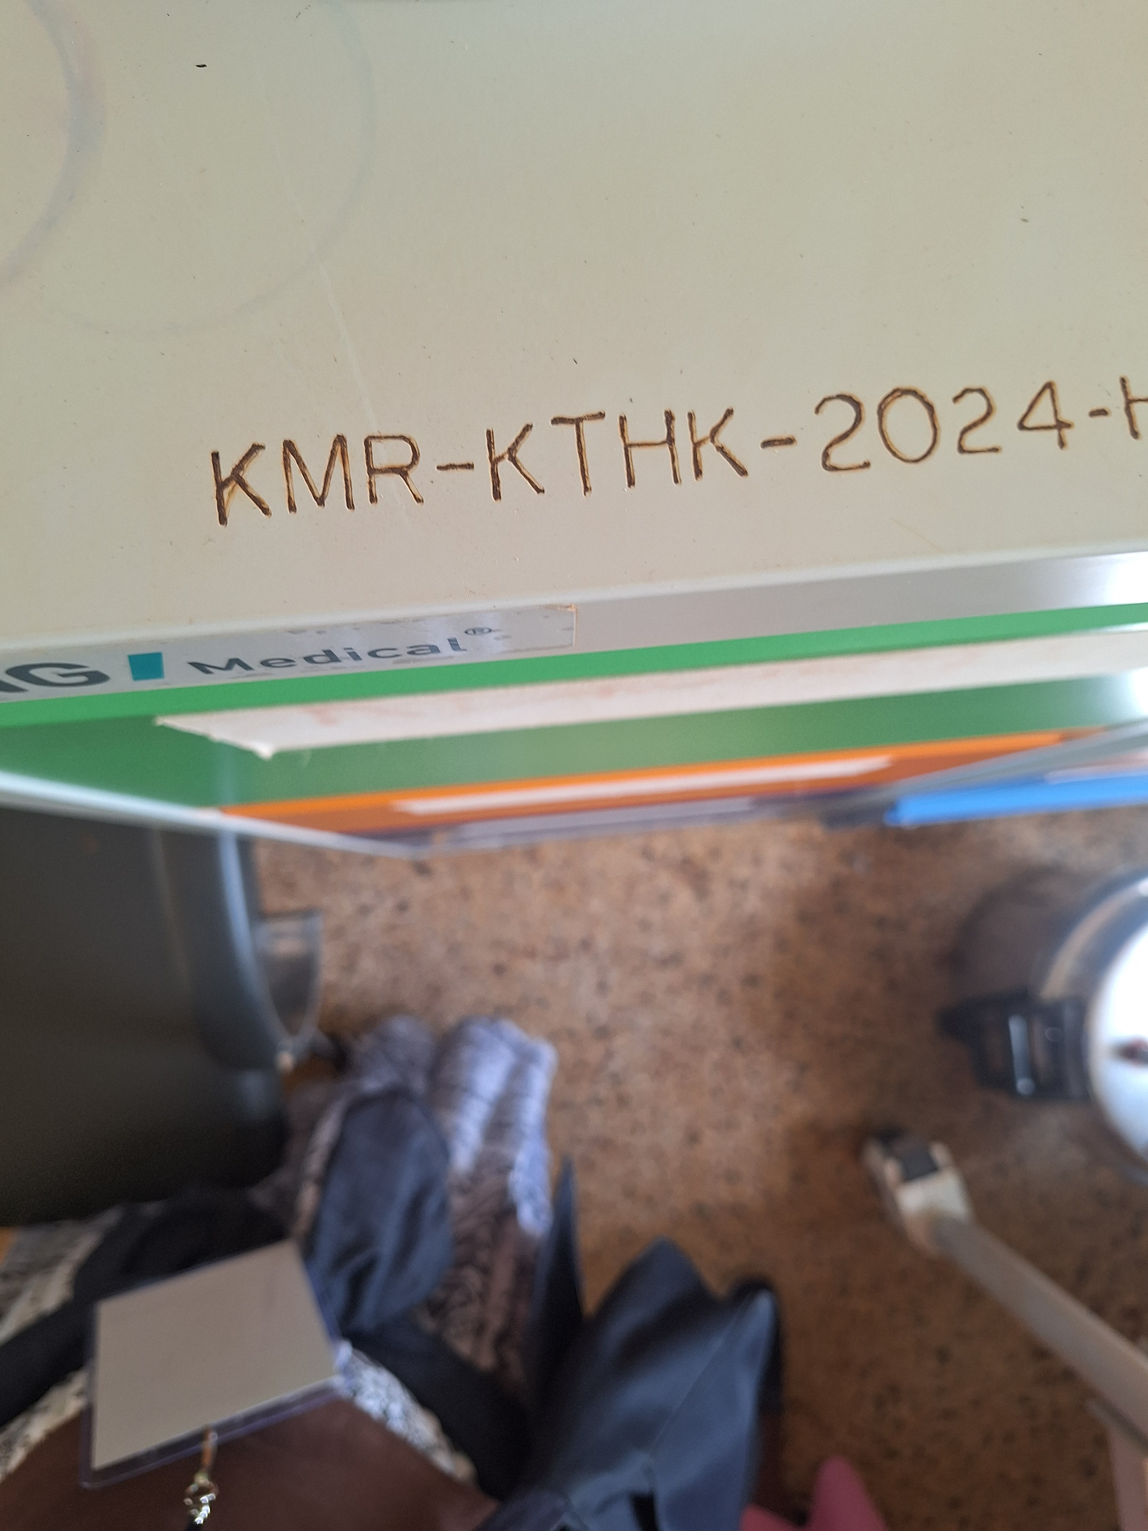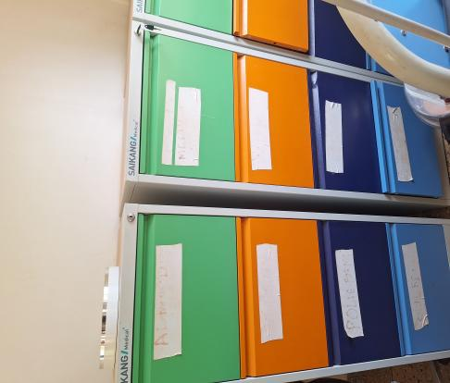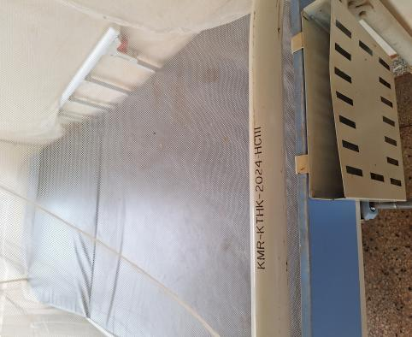

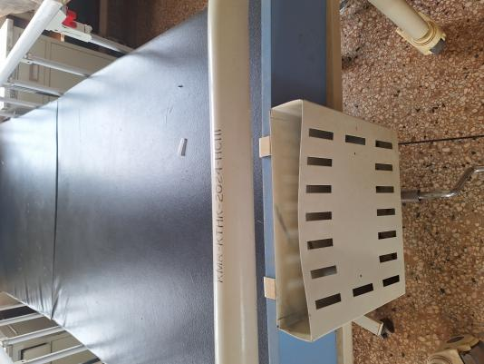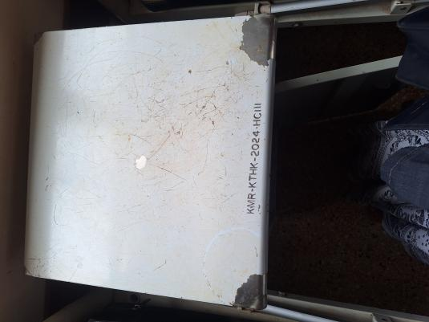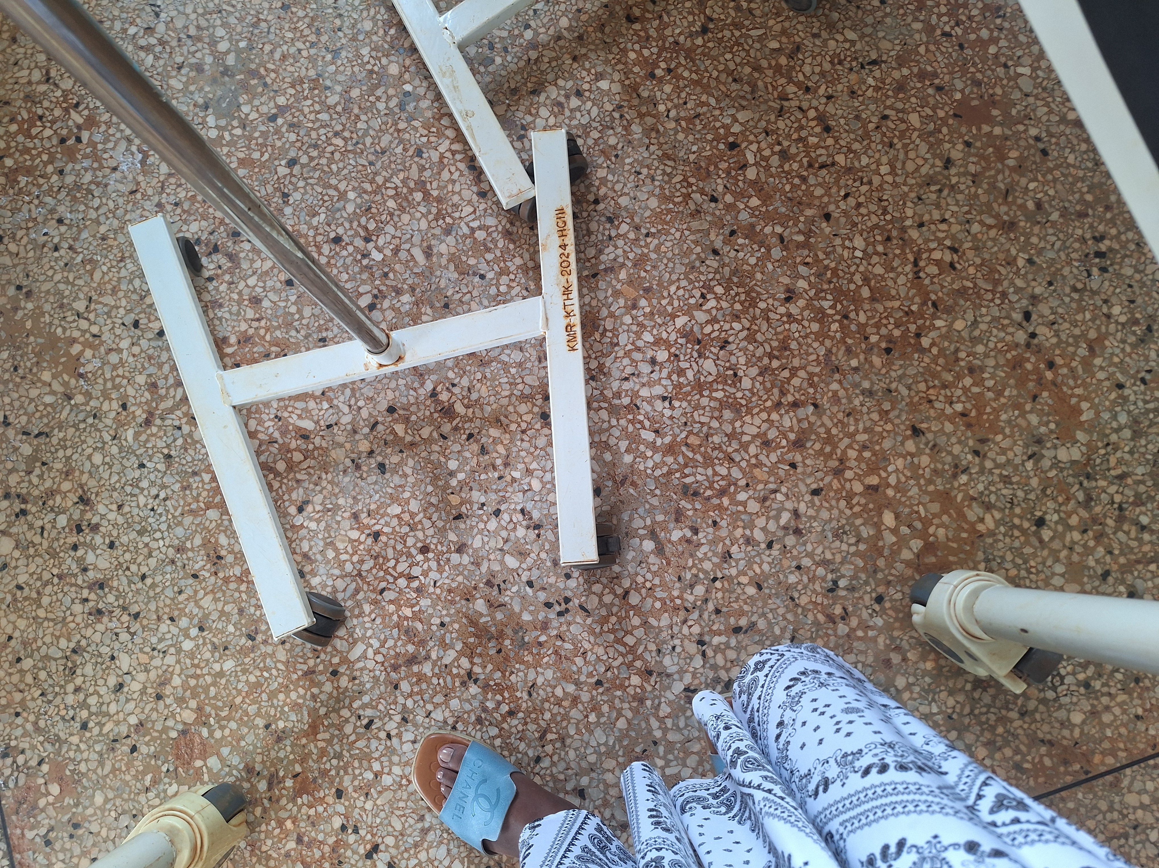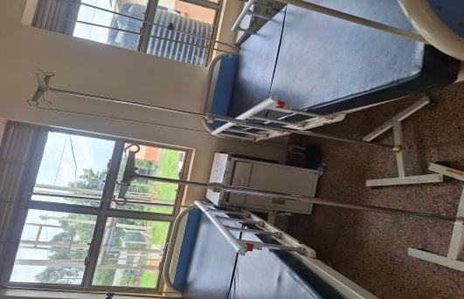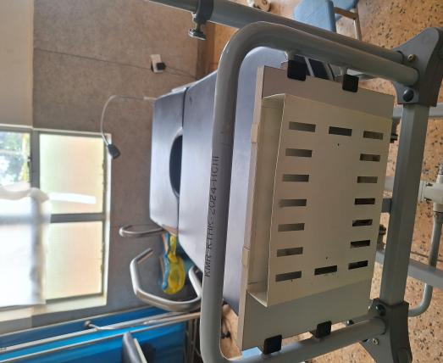
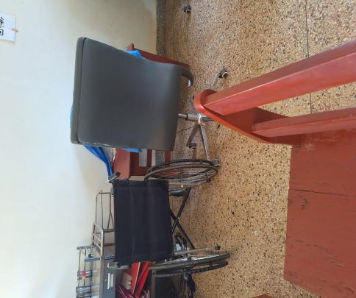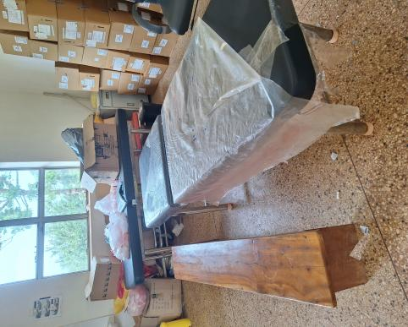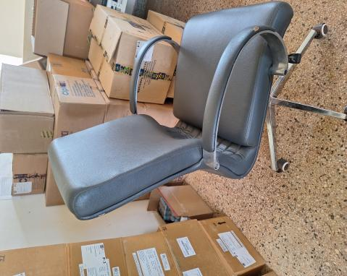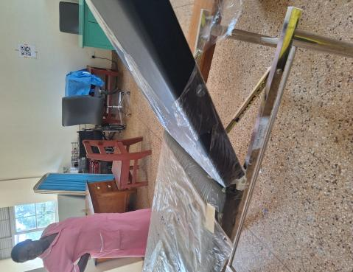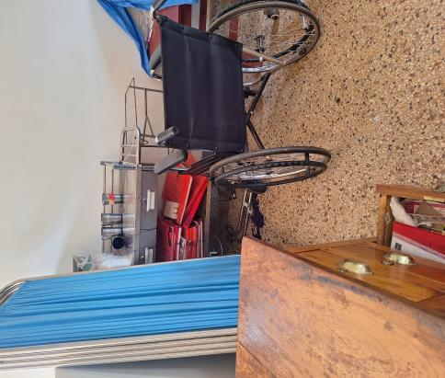

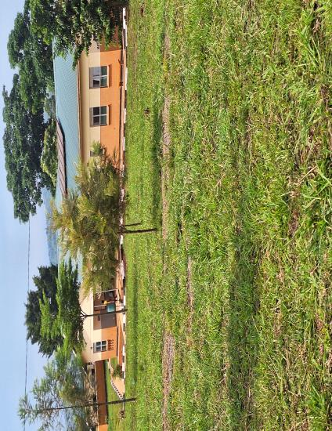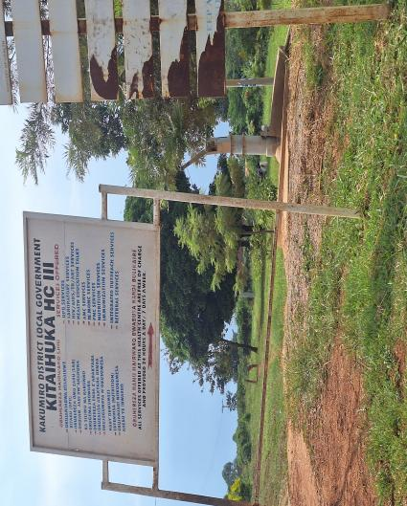

SCHOOL VERIFICATION CHECKLIST

SCHOOL INTERVIEW/DISCUSSION GUIDE

Name of school: ………………………………………………………………………………..

1a | Does the Facility have a record of all assets provided under UgIFT.  (Obtain a record and verify if it has the costs and numbers supplied
1b | If Not ask how many were supplied and when.

2 | How does this facility Maintain (repair/service/replace) the assets provided under Ugift

3 | Does the facility take regular record about functionality/ or breakdown of the assets provided?  Nonfunctional/ working, and reasons for non-functionality.

4 | How has the UgIFT support helped in service delivery in the area, any issues, challenges and any recommendations for better program implementation.

PROCEED TO VERIFICATION AFTER THIS DISCUSSION

SCHOOL FURNITURE
(School Desks, Office chairs, Laboratory stools, Book shelves)

Name of LG………………………………………………………………… Name of SCHOOL………………………………………………………………………………

Equipment/ Item | Department | Asset Number | Item  Description | Life in Months | Tag Number ( engrave no.) | Date Of Pur | Date Placed In Service | Recoverable cost | Cost | Acc Dep Cost | Net Book Value | Ytd Deprn | Equipment status | Remarks

ICT ITEMS TO VERIFY
(Desktop Computer, Server Processor, Network Switch 24 Port, Multipurpose Printer, UPS, Projector, Air Conditioners, Server, CCTV Camera)

Name of LG…………………………………………………………………………… Name of SCHOOL………………………….………………………………………

Equipment/ Item | Department | Asset Number | Item  Description | Life in Months | Tag Number ( engrave no.) | Date Of Pur | Date Placed In Service | Recoverable cost | Cost | Acc Dep Cost | Net Book Value | Ytd Deprn | Equipment status | Remarks

BUILDINGS TO VERIFY
(Non- Residential and Residential, Kitchen, Toilets/Pit latrine Water tanks, Fences etc.)

Name of LG…………………………………………………………………………… Name of SCHOOL………………………….………………………………………

Equipment/ Item | Department | Asset Number | Item  Description | Life in Months | Tag Number ( engrave no.) | Date Of Pur | Date Placed In Service | Recoverable cost | Cost | Acc Dep Cost | Net Book Value | Ytd Deprn | Equipment status | Remarks

